DLP Pilot Descriptive Results
June 22, 2026

Overview
Developed by Dr. Christopher Bernido and Dr. Maria Victoria Carpio-Bernido, Ramon Magsaysay Awardee Theoretical Physicists, the Dynamic Learning Program (DLP) is an activity-based curriculum fostering independent learning by having students read, write, and complete exercises before lessons are formally discussed in the classroom. The Philippines Department of Education (DepEd) recognized DLP as one of its alternative learning modalities (ADMs) to address key challenges in basic education such as overcrowded classrooms, multiple shifts, and class disruptions caused by emergency situations (e.g., disaster, conflict).
To evaluate program effectiveness, the Lab—together with the Principal Investigators—randomly selected 100 schools for each of three implementation contexts: a mainstream model for overcrowded classrooms, a shifting model for schools operating multiple shifts, and an emergency model for schools with frequent class disruptions. Procurement delays prevented the Department of Education's implementing unit from supporting standard pilot implementation, and the data collected is based on implementation-ready schools proceeding with their own resources. This report presents a dataset snapshot and descriptive statistics from all datasets provided by the implementing office.

DATASET PROCESSING
Using the program’s monitoring data as the base dataset, the final tagging (rev_status) for 258 schools show that only 41 schools implemented a DLP model (treatment)
Figure 1 summarizes the number of students from pilot schools based on enrollment data, baseline and endline assessments for Math and Reading. Across these schools, there were a total of 313,009 junior high school students who became part of the pilot. For reading proficiency, the pilot assessed 94 percent (295,755) students at the beginning of the school year (BoSY), and 80 percent (250,696) students at the end of the school year (EoSY) out of the total enrollment. For Math proficiency, the pilot also assessed 94 percent (294,804) during BoSY, and 91 percent (283,564) students during EoSY out of the total enrollment.

SCOPE OF ANALYSIS
The analysis draws exclusively on datasets provided by DepEd, including baseline and endline rounds of the Rapid Mathematics Assessment (RMA), the Philippine Informal Reading Inventory (Phil-IRI), and the implementing unit’s monitoring data. The monitoring data do not capture the specific DLP model implemented, the method of implementation, or the timing of implementation during the school year. Implementation rates reflect schools that were able to implement DLP using their own resources.

Figure 1. Enrollment and Assessment Counts among DLP Schools
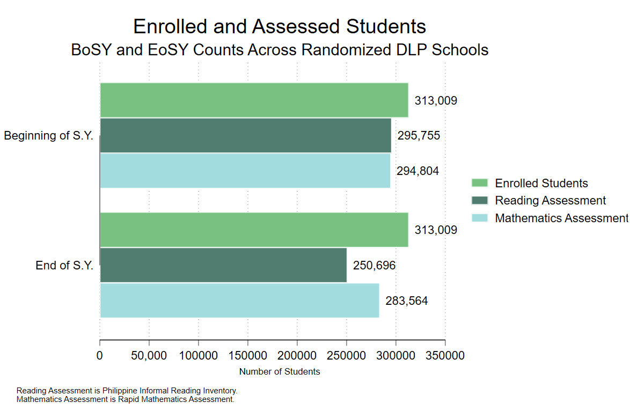

PROGRAM IMPLEMENTATION
Based on initial randomization records and implementation status (rev_status) data, 16 percent of the 258 schools assigned to a treatment arm (mainstream, shifting, or emergency) were able to implement DLP using their own resources. As the standard pilot rollout was still in preparation, these schools proceeded independently ahead of the full pilot launch. The share of schools that implemented DLP was highest among those assigned to the emergency model and lowest among those assigned to the mainstream model.
Table 1. Implementation rates, by treatment arm
Assignment group | Schools | Implementing schools | Implementation rate
Emergency | 87 | 16 | 18.4%
Mainstream | 85 | 10 | 11.8%
Shifting | 86 | 15 | 17.4%

Note: The current dataset cannot specify which DLP model these schools implemented. Hence, the compliance rates are based on whether they implemented a DLP model if they are assigned to a treatment arm, regardless of the model.

Figure 2 summarizes the implementation rates by treatment groups, showing that 17 to 18 percent of pilot schools initially assigned to emergency and shifting were able to implement a DLP model.

Figure 2. Implementation Rates by Treatment Assignment
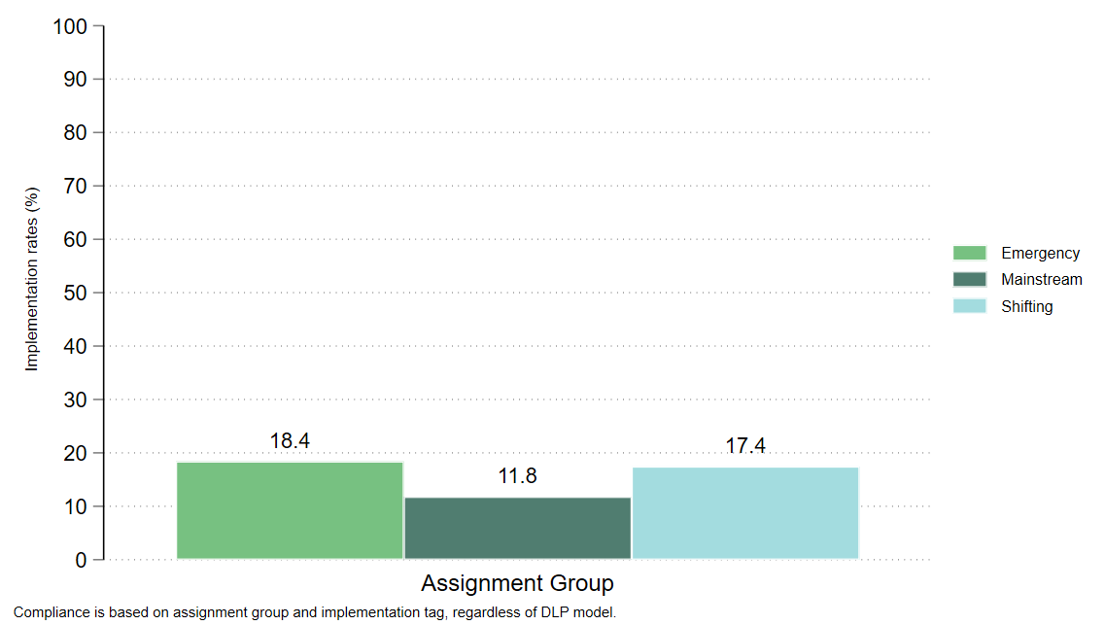

On the other hand, Figure 3 shows that NCR and Bicol regions had the highest shares of schools that were able to implement a DLP model with 23 percent and 18 percent implementation rates, respectively.
Figure 3. Implementation Rates by Region
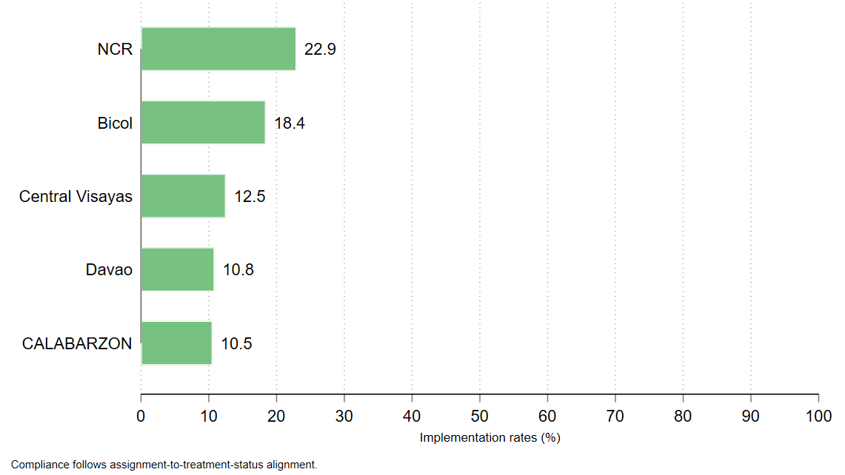

GEOGRAPHIC SUMMARIES
The randomized schools in this file are spread across five regions. Region 5 has the largest number of schools in the dataset. The coverage rates now use the enrollment denominators from the assessment dashboard files, so the regional rates stay below 100 percent.
Figure 4 shows that assessment coverage from BoSY to EoSY was relatively high across all regions.
Table 2. Implementation rates, by region
Region | Schools | Reading BoSY coverage | Reading EoSY coverage | Math BoSY coverage | Math EoSY coverage | Implementation Rate
Region 5 | 87 | 98.3% | 93.5% | 99.1% | 97.6% | 18.4%
Region 15 | 48 | 96.6% | 76.6% | 98.0% | 97.4% | 22.9%
Region 7 | 48 | 97.7% | 93.0% | 99.0% | 97.7% | 12.5%
Region 4 | 38 | 97.9% | 92.9% | 99.5% | 96.7% | 10.5%
Region 11 | 37 | 98.4% | 93.6% | 98.1% | 95.0% | 10.8%

Figure 4. BoSY and EoSY assessment coverage by region
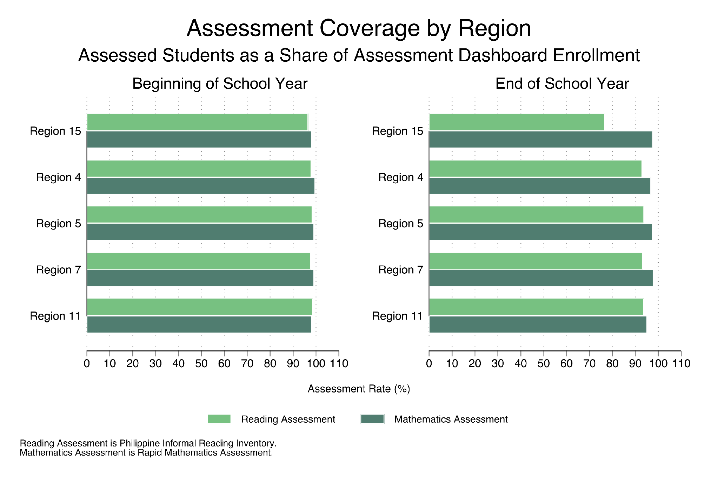

PROFICIENCY AND READING CATEGORIES (All Pilot Schools)
To assess the proficiency of Junior High School students in pilot schools, we leveraged the Rapid Mathematics Assessment (RMA) results to assess math performance, and the Philippine Informal Reading Inventory (Phil-IRI) results to assess their reading proficiency.
RMA results are concentrated in the not proficient group in BoSY and noticeably reduced by half in EoSY. This pattern is visible across Grades 7 to 10.
Table 2. Share of assessed students across Grade 7 to 10
Period | Group | Students | Share of assessed
BoSY | Not proficient | 257,630 | 87.4%
EoSY | Not proficient | 135,932 | 47.9%

For the Philippine Informal Reading Inventory (Phil-IRI), the BoSY data has separate 2-level and 3-level reading categories. The EoSY data does not have the same 2-level and 3-level fields, so the category independent is used as a proxy for grade ready in the comparison figures.
For Math, Figure 5 summarizes the shares of students assessed and their proficiency outcomes from BoSY to EoSY, showing a reduced number of “Not proficient” students across all grade levels. For Reading, Figure 6 shows an increased share of students who were “Grade ready” or independent readers and instructional readers.
Table 3. Share of independent readers from BoSY to EoSY
Reading measure | Category used | Share of classified students
Beginning of School Year 2-Level | Independent | 31.8%
Beginning of School Year 3-Level | Independent | 25.5%
End of School Year Proxy | Independent | 41.1%

Figure 5. Rapid Mathematics Assessment Proficiency by Grade Level
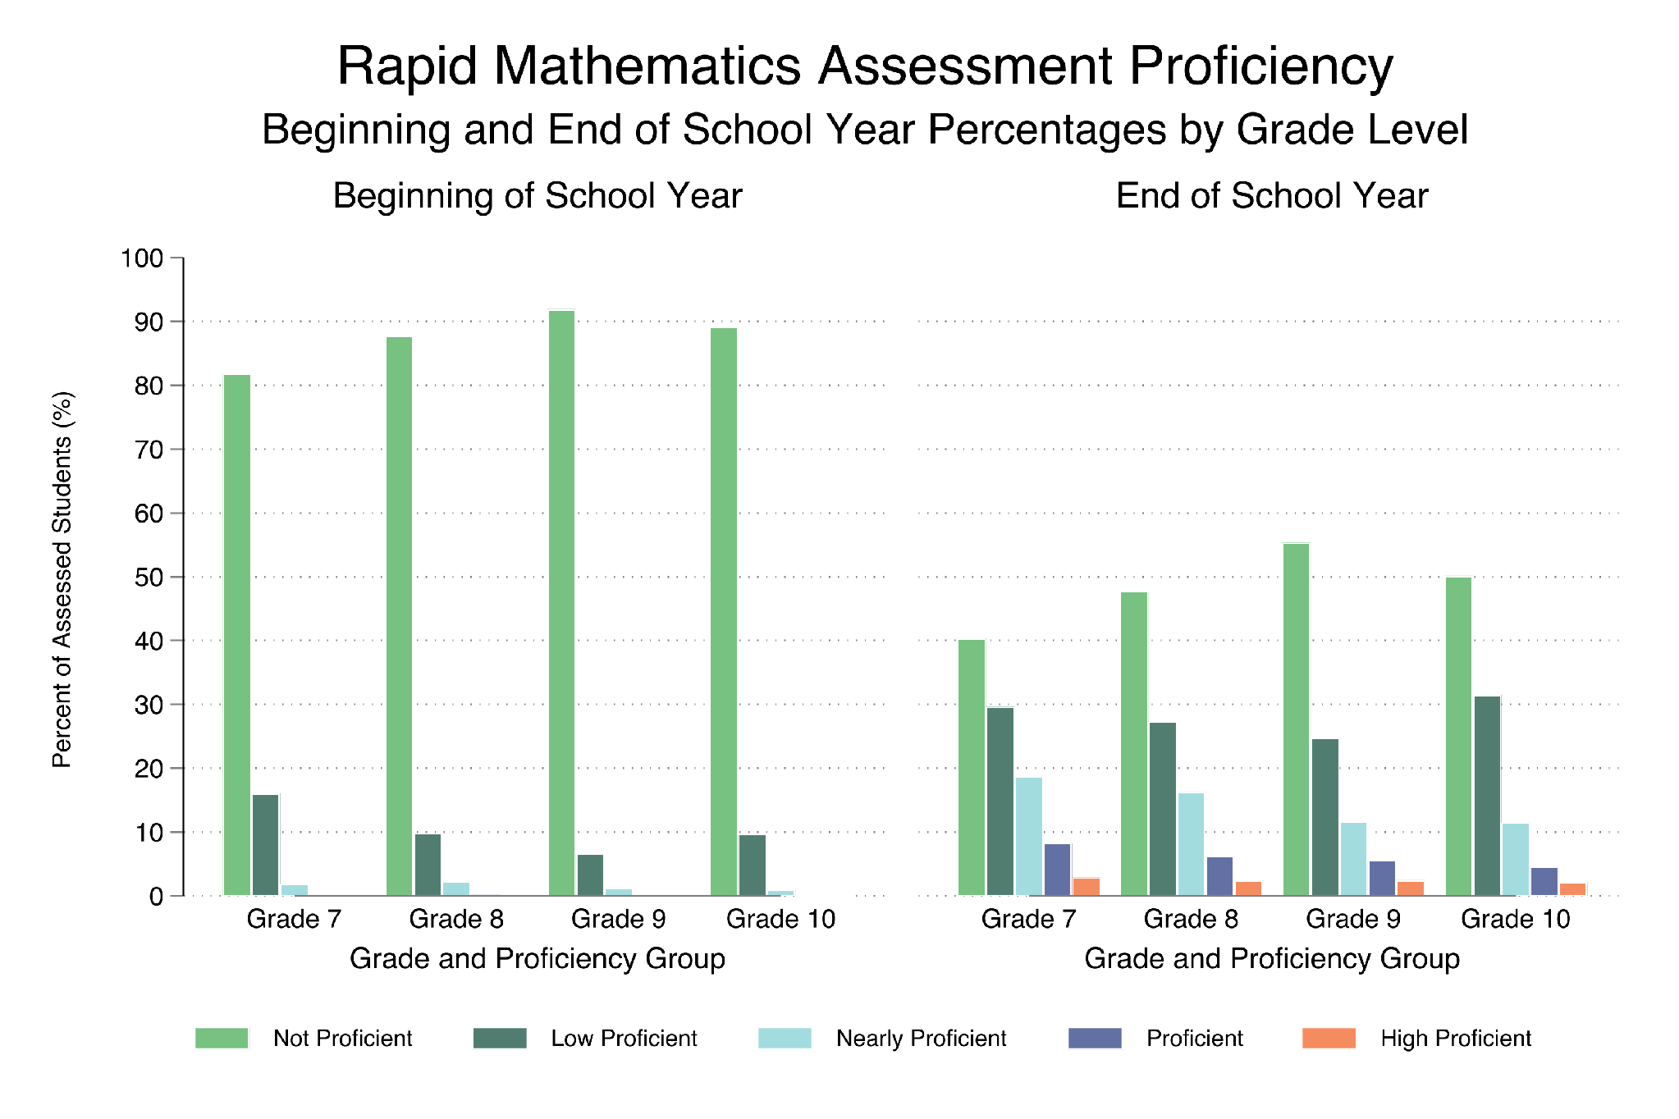

Figure 6. Philippine Informal Reading Inventory BoSY 3-Levels and EoSY Proxy by Grade Level
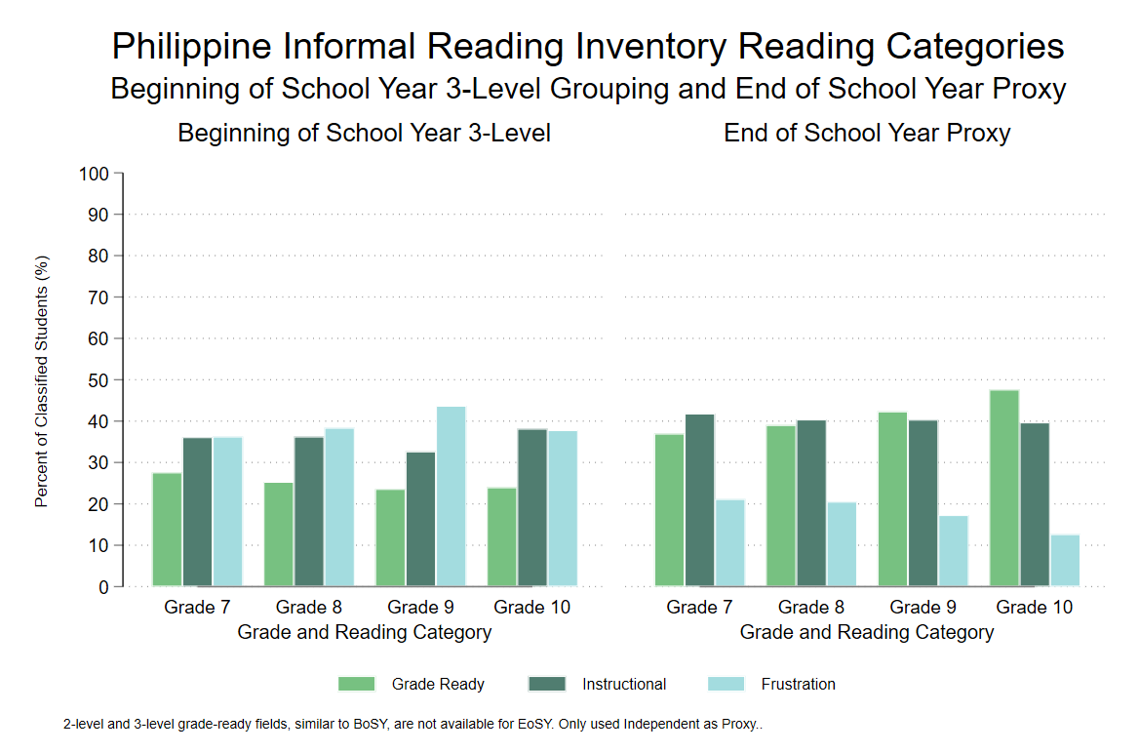

SUBGROUP PATTERNS (treatment group)
We also look into the Math and Reading score patterns of treatment schools by comparing BoSY and EoSY assessment scores.
For Math, Figure 7 shows an improvement of students' performance, as the share of students tagged as “Not proficient” reduced by 37 percent out of the total students assessed among treatment schools.

Figure 7. Rapid Math Assessment Shares in BoSY and EoSY by Treatment

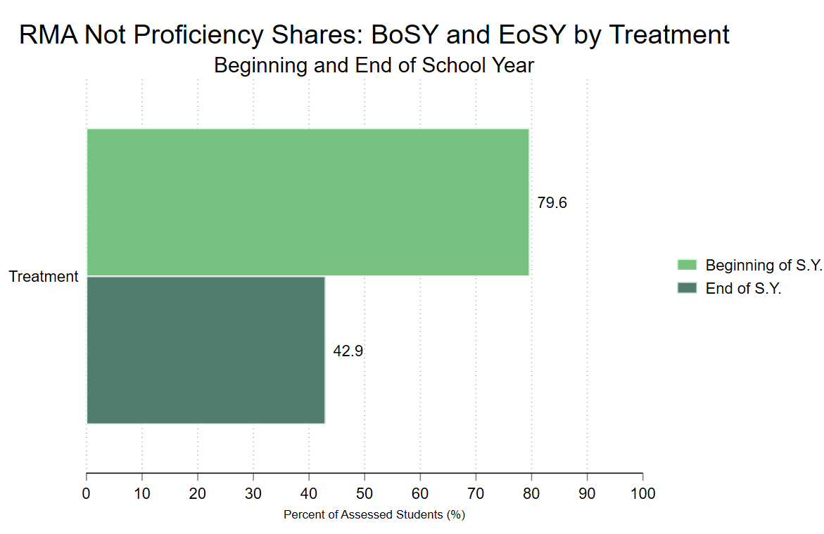
Note: Figures are in % share out of total assessed students

For Phil-IRI, BoSY uses the 2-level and 3-level independent categories.EoSY independent is shown as a proxy because the EoSY results do not include the same 2-level and 3-level fields. Using these indicators, Figure 8 shows an increased share of students reading at a grade ready level, or independently from BoSY to EoSY among treatment schools.

Figure 8. Phil-IRI Grade Ready (Independent) Share
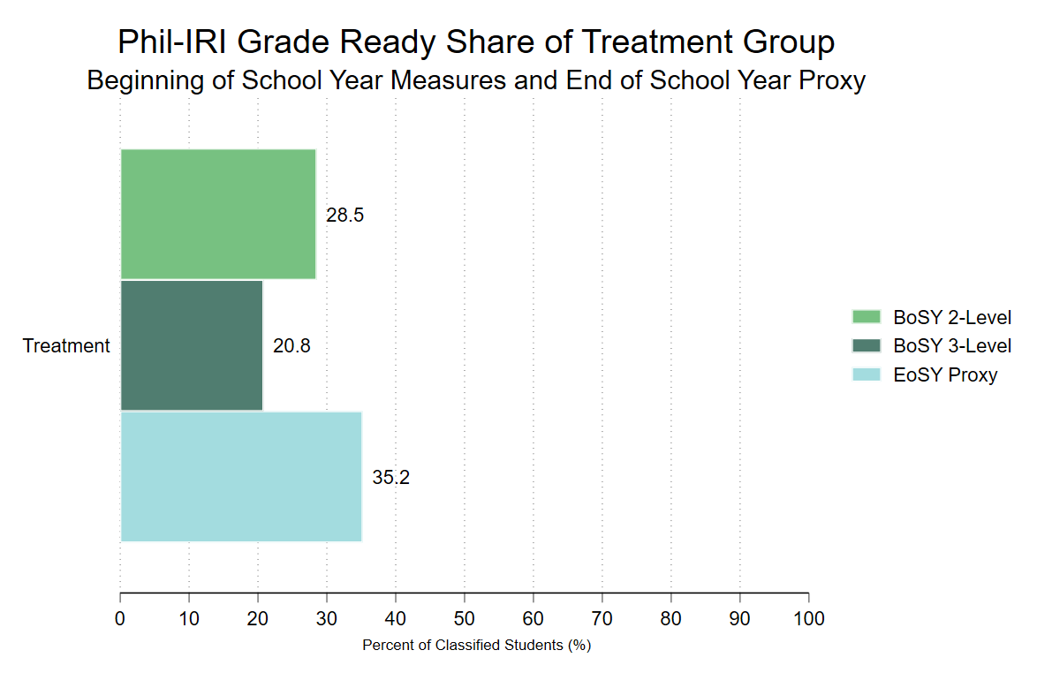
Note: Figures are in % share out of total assessed students

Preliminary Findings, Data Notes, and Implementation Recommendations
Data Notes and Constraints
- The analysis draws exclusively on datasets available through DepEd, comprising baseline and endline assessments for reading and mathematics, and monitoring data collected by the program owner.
- Implementation rates are based on the monitoring data provided, tagging schools whether they implemented a DLP model (binary: yes or no for control schools). It does not include information on which DLP model they implemented. Full compliance cannot therefore be determined from the available data.
- Monitoring data does not capture how DLP was implemented, or when it was implemented during the school year.
Preliminary Findings Interpretability
- The figures presented in this section are descriptive only. They are intended to characterize the current data and are not estimates of program impact.
- Control schools are excluded from the reading and mathematics performance figures. A treatment-control comparison is not meaningful at this stage and risks misinterpretation.
- The research team will conduct a deeper analysis of these findings in the coming weeks in coordination with the Principal Investigators.
Recommendations for National Rollout
- Conduct regular coordination across all governance levels: Schedule regular calls at central office levels and at field levels to check implementation progress. Flag any implementation issues as soon as possible for the research team to provide a resolution.
- Consider internal procurement timelines: DepEd should ensure all program materials are ready prior to national rollout, including modules available for printing throughout the school year.
- Test monitoring tools to ensure it captures program fidelity checks: Monitoring systems should be expanded to capture the specific DLP model each teacher is implementing, alongside implementation timing and fidelity. Real-time monitoring is strongly recommended.

rev_status refers to the tagging whether the school implemented a DLP model or not

